Student Name: Karikalan Rajendran

BI Project Assignment

**Executive Summary:**

Utilizing Microstrategy Business Intelligence tool to its full potential, the following report presents the performance analysis for the fast-food restaurant Blazing Burger. The Sales Performance Analysis indicates the performance of three restaurant locations with correlation to Physical location, Cuisine Type and day of the week. The key performance indicators for the three locations are Average Revenue, Average Score and Order count.

The analysis shows that performance of the Blazing Burger lower Manhattan location is reduced after Mid-February 2014, The Average Health score for the lower Manhattan location is analyzed to be poor, below the needed rating 28.

Following Visualization will give a visual representation of the performance of the Blazing Burger in all the three location.

Business Analytics Settings (Wrangling):

Script:



Day of the week: (Script to make the day of the week is short formats. Example: Saturday as Sat)

CaseV(DayOfWeek([Calendar Date]@ID), 1, "Sun", 2, "Mon", 3, "Tue", 4, "Wed", 5, "Thu", 6, "Fri", 7, "Sat")

**Blazing Burger Performance Analysis:**

Worksheet 1:

**Revenue Trends:**

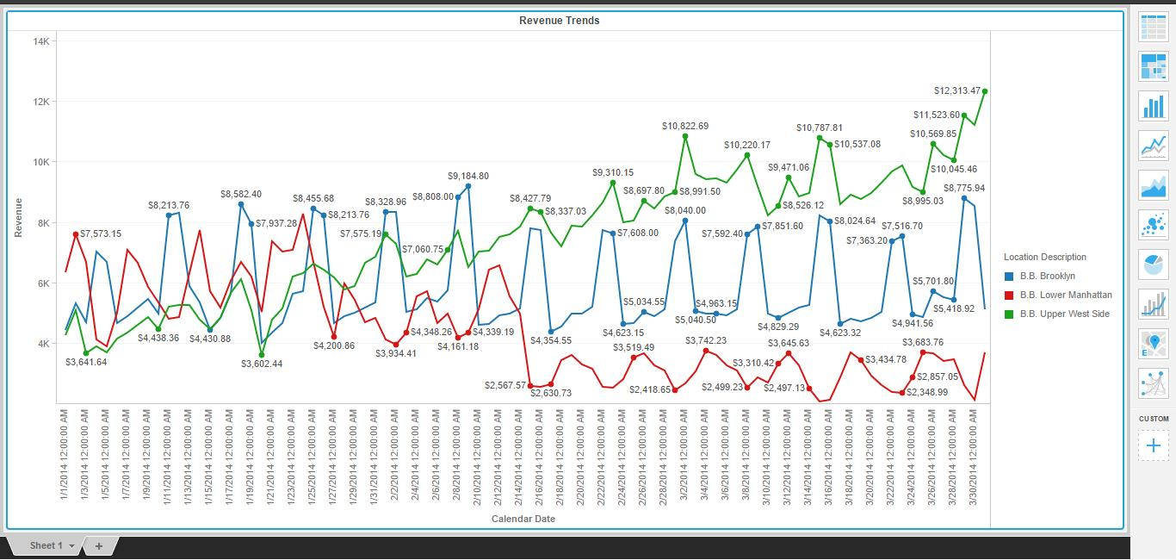

The Revenue Trend shows that after Mid of February the performance of the Lower Manhattan location has reduced.

**Avg Revenue vs Order Count by Day of Week:**

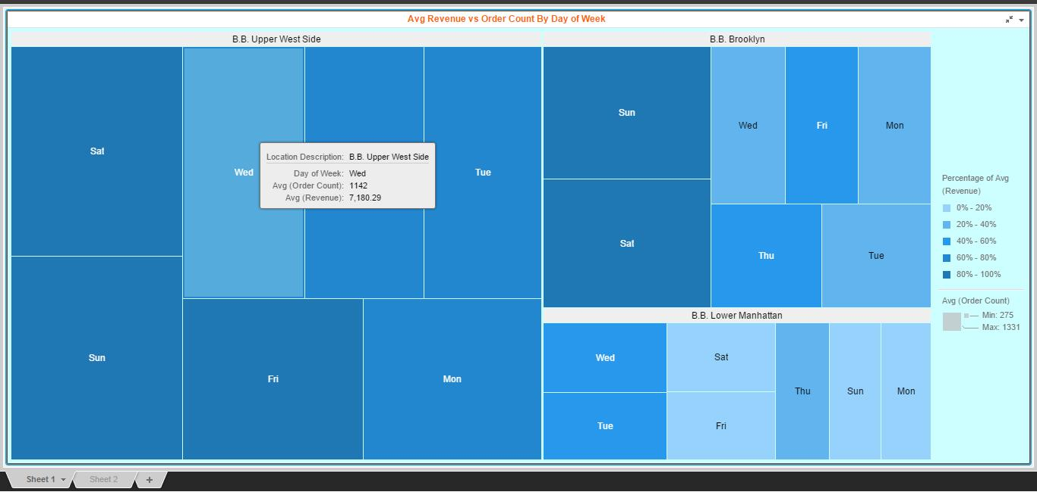

The above analysis shows that on Saturday, Sunday and on Friday, the Avg Revenue generated and Avg Order count for the Lower Manhattan Region is less.

**Order and Item Count Correlation:**

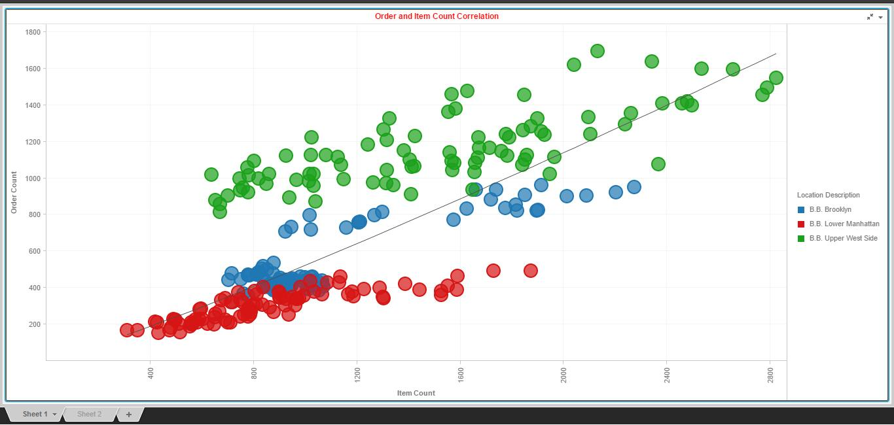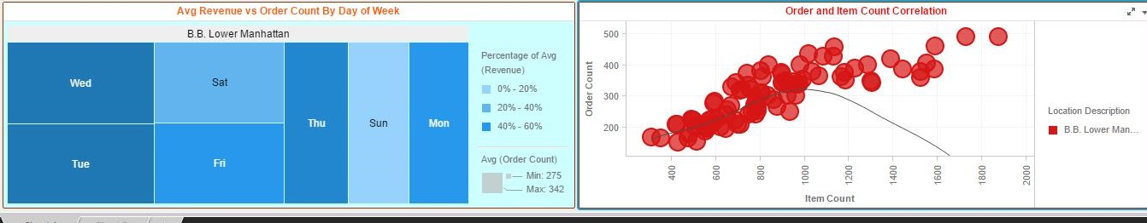

The Above Trending (With Trend line) shows at Lower Manhattan location, the order count has reduced over time.

**Avg(Scores) by ZipCode:**

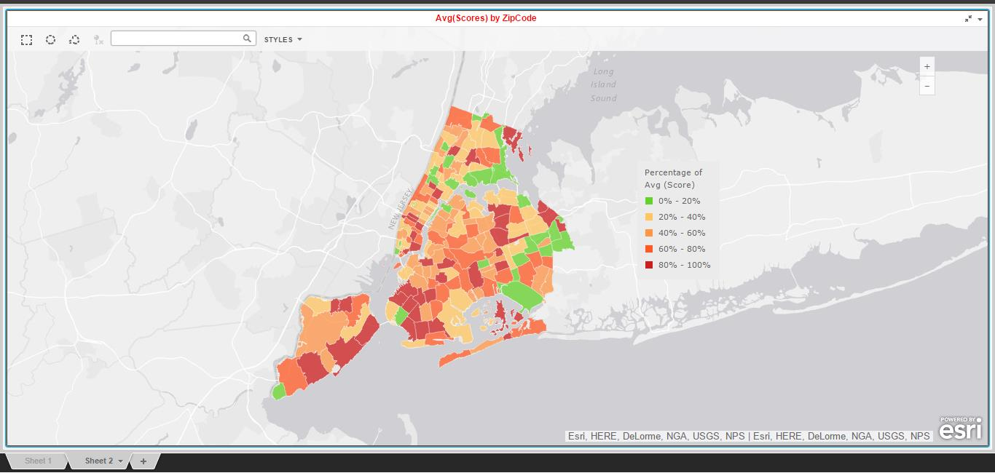

The Average Score at Lower Manhattan location is less (Green). This could be due to local Issues and Population in that Location.

**Revenue Performance vs Avg Health Score:**

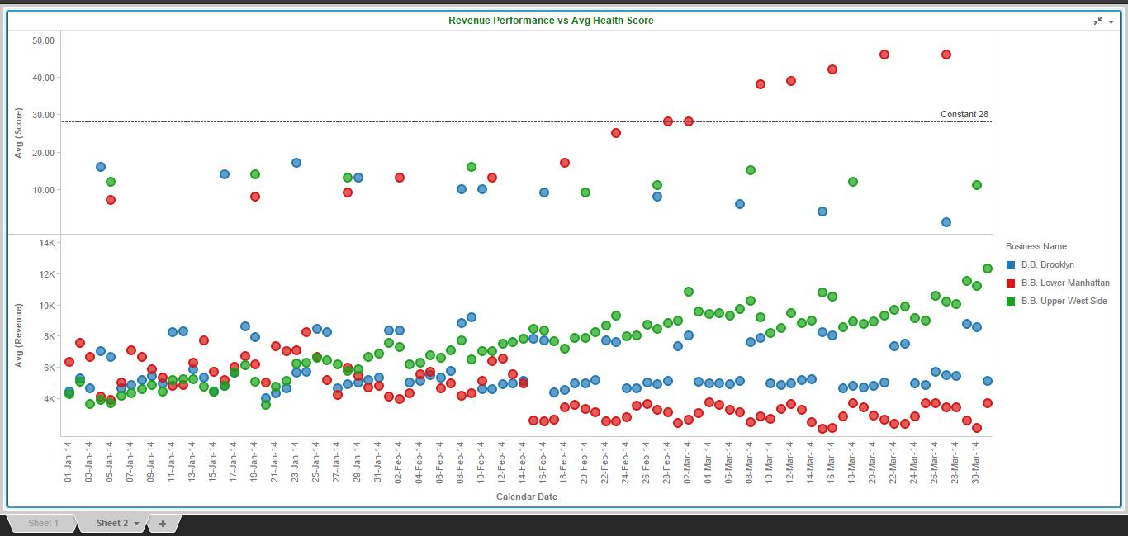

It’s Clear from the above analysis that Avg Health Score for the Lower Manhattan Location has risen above the constant 28.

**Avg(Scores) by Boro:**

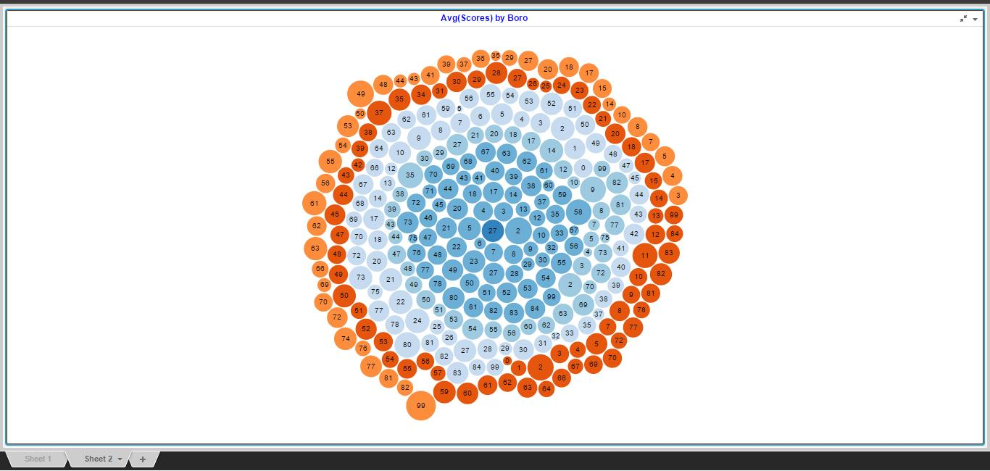

Worksheet 1:

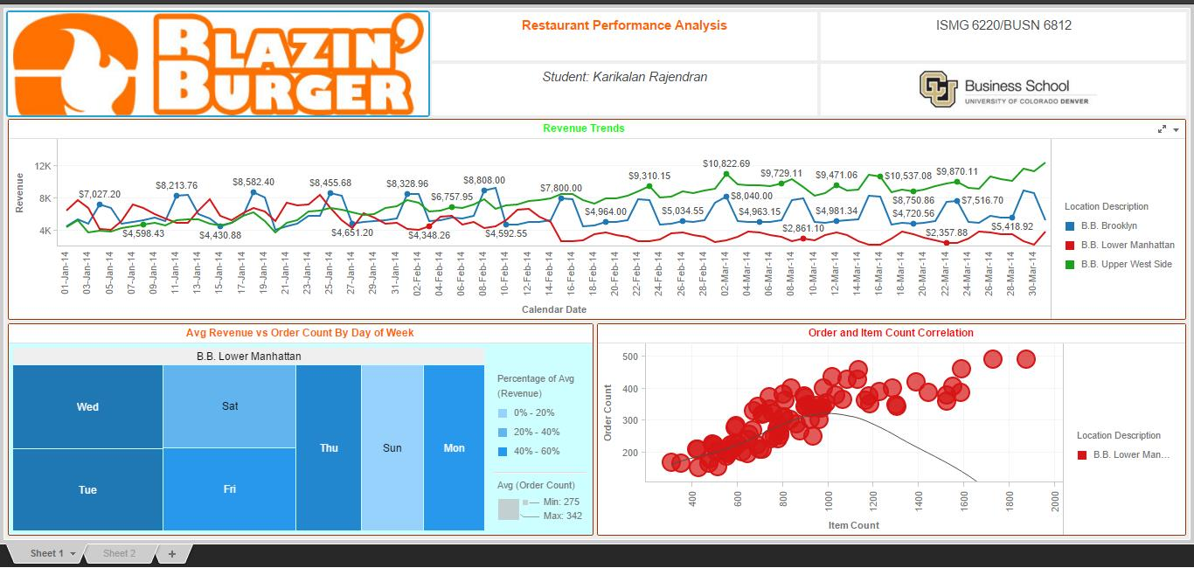

Worksheet 2:

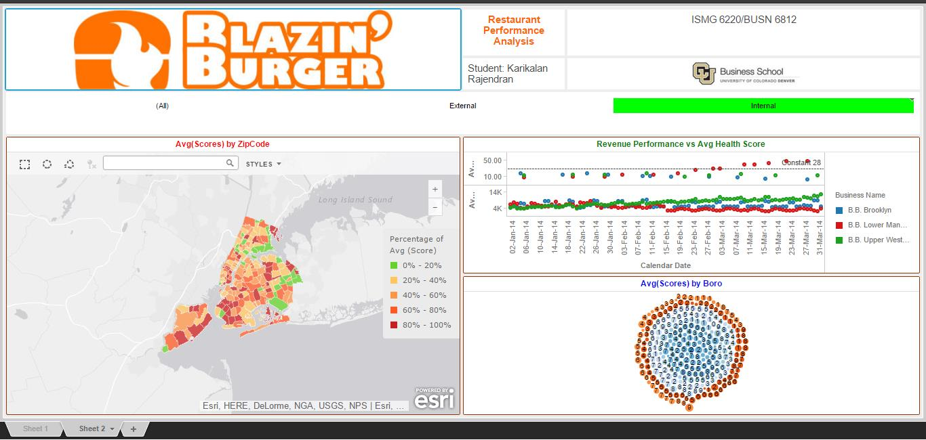

Strengths/weaknesses of Micro Strategy BI Tools*:*

Strength: Strong Visual representation charts

Weakness: Data error can cause irregular Analysis

Recommendations*:*

Double check data before uploading the data into the dataset.

Use filters to make best use of the Analysis and correlation feature